Evergreen Region Letter of Intent
This Letter of Intent (LI) documents the commitment a player and his/her parents are making to a team.
According to the Evergreen Region Participants’ Handbook, to make a binding
commitment, the following must occur:
1. This LI must be signed by the player, parent/legal guardian, and the club representative; and
2. the player must be a registered member of the Evergreen Region.
By signing this LI, the player, his/her parents, and the club, are agreeing to the following:
1. the player shall be a member of the named team in the Evergreen Region for the entire season as indicated below;
2. the player may not sign more than one (1) LI for a given season;
3. the player’s season shall be defined as starting when the player is both registered with the region AND has signed the LI, and stopping at the official end of the team’s season when termination information is received by the region office; and
4. all transfers will occur according to the transfer rules in the Participants’
Handbook.
**Terms of the Letter of Intent may be appealed. All parties are entitled to due process through the ERVA appeals process.**
I understand that by signing this LI, I am committed to the club indicated below and have read all terms and conditions in this document. I have discussed them with the club representative named within, and I fully understand, accept, and agree to be bound by them.
Player’s Name: _________________________________ Signature: __________________________________
Date:___________
Address: _________________________ City: _____________________State: _________
Zip:____________
Parent/Guardian’s Name: _____________________________ Signature: _____________________________
Date: __________
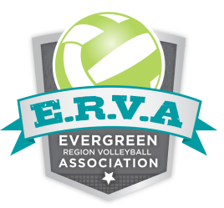
Club Rep’s Name: ___________________________________ Signature: ______________________________
Date:__________
Club: _________________________ Team:_______________________
Season Year: 2013-2014

